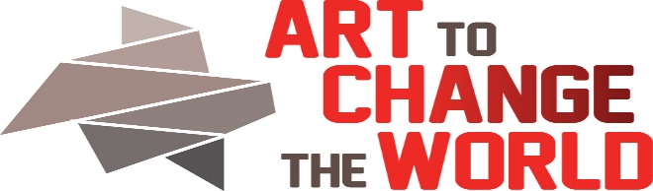
_________________________________________________________________________________
2323 Monroe St. NE, Minneapolis, MN 55418 https://www.ArtToChangeTheWorld.org
Intern/Mentee Application
The mission of ACW is to build a supportive community of voices who aspire to encourage change through positive knowledge, collaboration, and sometimes humor. We seek artists, scientists, educators, change makers and all supporters to meet at the intersection of art and natural and social sciences.
Applications will be reviewed on a rolling basis. Employment starts immediately. Approximately $500 from now until Oct 2018.
Date of Application Submission:
Event: See. Say. DO-Art To Change The World (SSD-ACW) Oct 5-15, 2018
Intern/ Mentee Name: Email:
Address: Phone:
URL(s):
Media (s):
Attach a resume if you have one.
Answer the following:
Please list the experience(s) and skill sets you could contribute to See. Say. DO-Art To Change The World (SSD-ACW) .
If you are an artist, please list your medium and describe your topics and where you have shown your work.
What is your preferred salary range per hour?
Are you a member of an under-served population?
Return this Artists application to: Director: Barbara Rogers Bridges. drb@bridgescreate.com. Call 612 – 845-0416 with any questions. Review Committee will include Director, Board Members, Social Practice Artist(s), and Outside Juror(s) who may be counselors, scientists, and other community collaborators.

