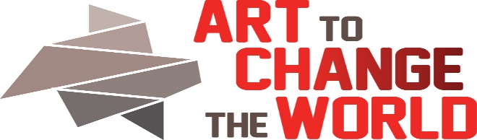

2323 Monroe St. NE, Minneapolis, MN 55418 , ArtToChangeTheWorld.org
Authentic/Expert Voice Application
The mission of ACW is to build a supportive community of voices who aspire to encourage change through positive knowledge, collaboration, and sometimes humor. We seek artists, scientists, educators, change makers and all supporters to meet at the intersection of art and natural and social sciences.
What is an Authentic/Expert Voice? We have added the word “authentic” to help explain the concept of what we need for “expert” voices in our event. We might also call these integral team-mates a “primary source voice.”
Our concept is that all of the team members (artist, authentic voice, supporters) learn from the other team members. One topic, Recovery, will have an author who is in recovery from addiction and a treatment center health care worker as team-mates. The entire team of artist, authentic/voice(s) AND the audience will all CONSTRUCT the new knowledge we discover by synthesizing ALL our data streams together. This approach is incredibly empowering, expands the diversity of voices represented, effects change and takes the pressure off the teacher/leader. The team builds the framework and the participants fill it in.
Application due on June 1, 2018. Review Committee will include Director, Board Members, Social Practice Artist(s), and Outside Juror(s). Return to ACW Director, Barbara Bridges: drb@bridgescreate.com. Call with any questions: 612 – 845-0416
Expectations:
1. Interactive talks with your artist, as they create the work and leading up to the October event, and with viewers on opening night, October 5, 2018. and perhaps during the period of the exhibition in some way. Our model is trying to move beyond the lecture/panel format. We are attempting to partner with our viewers- not talk at them. Help us invent a new paradigm! $200 stipend is planned.

2. Selective Artists are planning a workshop the following day, Saturday Oct 6, 2018. If you are involved in the planning and presentation of the October 6, 2018 workshop, a $300 stipend is planned.
Event: See. Say. DO-Art To Change The World (SSD-ACW) Oct 5-15, 2018
Your Name/Title: Email:
Address: Phone:
URL(s):
Artist Partner: Artist Partner email:
Area of Expertise/Experience (Short bio max 200 words and a bio picture (1800 pixels on the longest side and a resume (max two pages).
Please describe what message/data you might bring to our conversation (max 200 words. What do you want to share with our community and audience?
Please include 3 data sources for your artist team mate and our pre-workshop website resource center.

