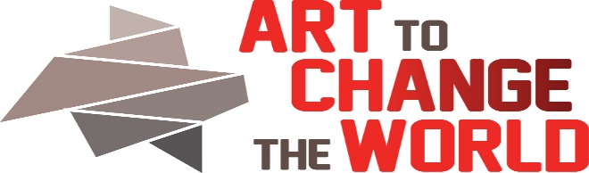

2323 Monroe St. NE, Minneapolis, MN 55418 https://www.ArtToChangeTheWorld.org
Artist Application
The mission of ACW is to build a supportive community of voices who aspire to encourage change through positive knowledge, collaboration, and sometimes humor. We seek artists, scientists, educators, change makers and all supporters to meet at the intersection of art and natural and social sciences.
Applications will be reviewed on a rolling basis. You must be an ACTIVE Member of ACW to submit. See Member Expectations here: https://www.arttochangetheworld.org/mission/
Application due on April 1, 2018. Review Committee will include Director, Board Members, Social Practice Artist(s), and Outside Juror(s). Return to ACW Director, Barbara Bridges: drb@bridgescreate.com. Call with any questions: 612 – 845-0416
Date of Application Submission:
Event: See. Say. DO-Art To Change The World (SSD-ACW) Oct 5-15, 2018
Artist’s Name: Email:
Address: Phone:
URL(s):
Media (s):
Artist Statement. DRAFT statement for the work which will appear in the October show. (max 200 words). This will NOT be your final artist statement. Look at this as an opportunity to get started. If you plan a series- write for that.
EXACTLY what do you need to best show your work? Be specific about space and special technological requirements. The Event committee needs this information.
Considering the theme- See. Say. DO-what are you willing to contribute to transforming the building and the event to an alternative universe? This would be over and above your specific exhibition space. Brainstorm here:
Authentic/Expert Voice Partner
Expectations:
1. Interactive talks with your artist, as they create the work and leading up to the October event, and with viewers on opening night, October 5, 2018. Our model is trying to move beyond the lecture/panel format. We are attempting to partner with our viewers- not talk at them. Help us invent a new paradigm! $200 stipend is planned.
2. Selective Artists are planning a workshop the following day, Saturday Oct 6, 2018. If you are involved in the planning and presentation of the October 6, 2018 workshop, a $300 stipend is planned.
Authentic/ Expert Name:
Address: Phone:
Email: Website(s):
Make sure your expert voice partner sends a completed speaker application to director, Barbara Bridges. drb@bridgescreate.com. The Authentic/Expert voice does not have to be a member of ACW
You must be an ACTIVE Member of ACW to submit.. Artists will be responsible for insuring their own work.
Return this Artists application to: Director: Barbara Rogers Bridges. drb@bridgescreate.com. Call 612 – 845-0416 with any questions.
Review Committee will include Director, Board Members, Social Practice Artist(s), and Outside Juror(s) who may be counselors, scientists, and other community collaborators.

