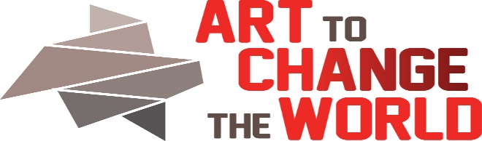

2323 Monroe St. NE, Minneapolis, MN 55418
ArtToChangeTheWorld.org
Director: Barbara Rogers Bridges
612 – 845-0416
Expert Voice Application
The mission of ACW is to build a supportive community of voices who aspire to encourage change through positive knowledge, collaboration, and sometimes humor. We seek artists, scientists, educators, change makers and all supporters to meet at the intersection of art and natural and social sciences.
Date of Application Submission:
Event: October 2018
Name/Title:
Email:
Address:
Phone:
URL(s):
Area of Expertise/Experience:
Artist Partner: Artist Partner email:
Please describe what message/data you will bring to our conversation (max 200 words), based on conversations you have had with your artist.
Describe how you will use your partner’s art work to deliver your message (max 200 words).
Please indicate your willingness to participate in:
- Interactive talks with your artist and viewers on opening night. This event is trying to move beyond the lecture/panel format. We are attempting to partner with our viewers- not talk at them. Help us invent a new paradigm.
- Interactive Same-Day Workshop. The ACW events will be a one day commitment for all the participants.
Please include a digital one paragraph biography(max) 200 words, a bio picture (1800 pixels on the longest side and a resume (max two pages).
Please include 3 data sources for our pre-workshop website resource center.
Review Committee will include Director, Board Members, Social Practice Artist(s), and Outside Juror(s).
Return to Barbara Bridges: drb@bridgescreate.com. Call with any questions: 612 – 845-0416

