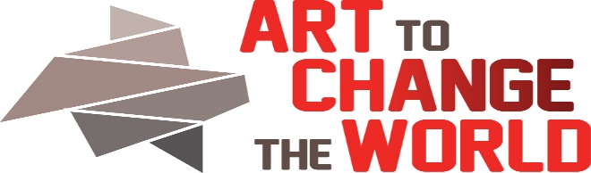

2323 Monroe St. NE, Minneapolis, MN 55418
https://www.ArtToChangeTheWorld.org
Director: Barbara Rogers Bridges
612 – 845-0416
Artist Application
The mission of ACW is focused on building a supportive and positive community of voices who aspire to encourage change by using positive knowledge, collaboration or humor as the agent of change.
Applications will be reviewed on a rolling basis. You must be a Member of ACW to submit.
Date of Application Submission:
Event: (Circle One) What’s Your Issue 2019? Found in Our Waters 2020.
Artist’s Name:
Email:
Address:
Phone:
URL(s):
Media (s):
Artist Statement. (General Statement) Describe what you create and why? (max 200 words)
Answer A or B.
- Are you submitting an already existing work for this exhibition/event?
- Please include your bio photo, short bio paragraph (max 200 words), and resume (one page).
- Please include 3 photos (jpg) or work samples (dance, music, writing etc ). Include website URLs if you have them. Describe media, give dimensions (HxWxD) and price(s). Please submit all photos no larger than 1800 pixels on the longest side. 300 DPI. Please submit UTube URLs if you are sending a video.
- Please submit an artist deconstruction statement for your work (max 300 words). Please explain the who, what , when, where or why.
- Please describe the change you hope to encourage with this work (max 200 words)

- Are you creating a new work for this exhibition/event?
- Please include your bio photo (1800 pixels on the longest side, short bio paragraph (max 200 words), and resume (one page).
- Please include 3 photos (jpg) or work samples (dance, music, writing etc ). Include website URLs if you have them. Describe media, give dimensions (HxWxD) and price(s). Please submit all photos no larger than 1800 pixels on the longest side. 300 DPI. Please submit UTube URLs if you are sending a video.
- Please submit a proposal for your NEW work (max 300 words). Please explain the who, what, when, where or why.
- Please describe the change you hope to encourage with this work (max 200 words).

Expert Voice Partner
Our events will include opening day/night interactive discussions and workshops with the expert voices speaking to/for your issue. The ATCTW events will be a one day/night commitment for ALL participants.
Expert Voice Data: Please send Barbara Bridges documents and/or URLs about your topic for addition to the pre-review website.
Expert Name:
Title:
Address:
Phone:
Email:
Website(s):
Make sure your expert voice partner sends a completed speaker application to director, Barbara Bridges.
You must be a Member of ACW to submit. The Speaker does not have to be a member of ACW.
Artists will be responsible for insuring their own work.
Return this Artists application to:
Director: Barbara Rogers Bridges. drb@bridgescreate.com. Call 612 – 845-0416 with any questions.
Review Committee will include Director, Board Members, Social Practice Artist(s), and Outside Juror(s) who may be counselors, scientists, and other community collaborators.

